Hajj - The Fifth Pillar of Islam
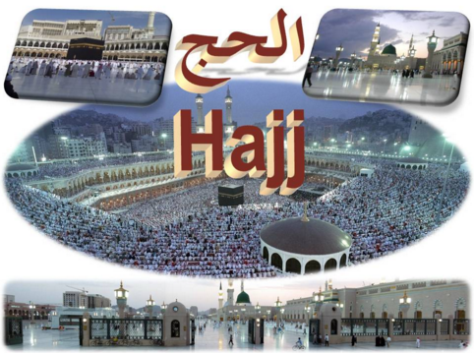

Quranic verse:

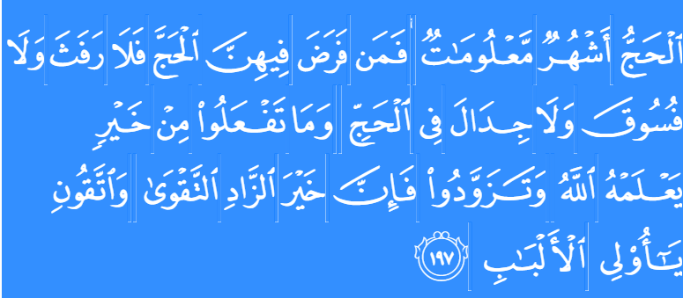SAHIH INTERNATIONAL

Hajj is [during] well-known months, so whoever has made Hajj obligatory upon himself therein [by entering the state of ihram], there is [to be for him] no sexual relations and no disobedience and no disputing during Hajj. And whatever good you do - Allah knows it. And take provisions, but indeed, the best provision is fear of Allah . And fear Me, O you of understanding

Summary Of Hajj Days:
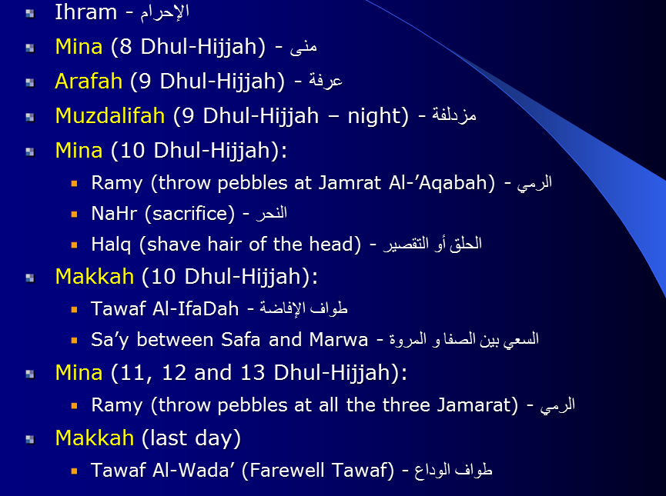

Pillars of Hajj and 'Umrah:
Pillars of Hajj are four: 1- Ihraam. 2- Tawaaf. 3- Sa'y between as-Safaa and al-Marwa. 4- Staying in Arafah from Dhuhr to Maghrib.

DAY 1
8th Dhul Hijja
Ihram –Wear Ihram
Declare Intention:

Then leaving for Mina :
keep saying talbiyah during Hajj Days
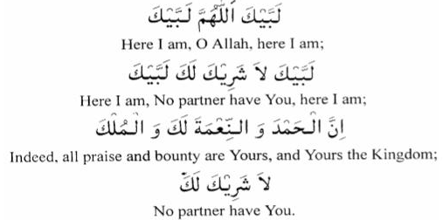

DAY 2:
9th dhul hijjah - Arafat Significance:
- Hajj is arafah –It’s the base on which everything else in Hajj is built.
- The Best Dua one can make is the Dua on Arafat Day.
- Prophet (peace be upon him ) gave his farewell sermon in Arafah.

"The best du'aa is the du'aa in the day of 'Arafah and the best thing I and the Prophets before me have ever said is: Laa Ilaaha ill-Allah wahdahu laa Shareeka lah!" [Malek and at-Tirmidhi].
On 9th of dhul Hijjah pilgrims travel from Mina to Arafah 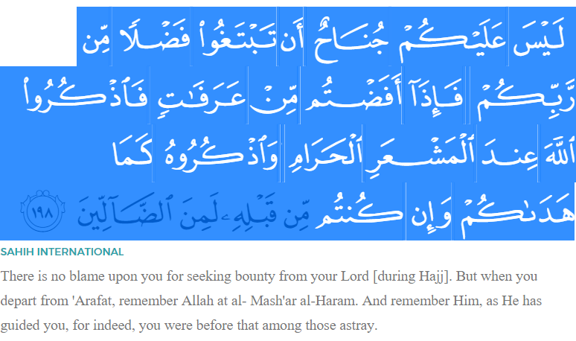
Hadith:
1)"There are no other days on which good deeds are more beloved to Allah than on these (Ten) Days." Somebody asked: "O Messenger of Allah! Not even Jihaad in Allah's way?" He replied: "Not even Jihaad in Allah's way; except for a person who went out (for Jihaad) with his self and wealth and came back with none." [Al-Bukhaari, Abu Dawud, at-Tirmidhi, ibn Maajah, Ahmad and ad-Daarimi]
2)The Prophet (S) said,
"Hajj is 'Arafah." [Ahmad and at-Tirmidhi].
The pilgrim must be at 'Arafaat on the ninth of dhil Hijjah after Dhuhr time. Anyone, who misses Arafaat day, his, or her, Hajj is void. All the scholars said in consensus that this pillar is the most important one.
The Prophet said, "Hajj is only valid by attending `Arafah." [At-Tirmidhi, an-Nassaa'i, Abu Dawud, Malek and ad-Daarimi]
Muzdalifah(9 dhul hijjah –Night)
- When sun set you leave Arafat for muzdalifah ,going with calmness and tranquilty.
- Make sure you don’t leave until after sunset.
- Do not performs prayers in Arafat and enroute to muzdalifah.
- Maghrib will be performed with isha in muzdalifah.
- It is Sunnah to spend night in muzdalifah .
- Collect pebbles for 10th dhul hijjah -7 pebbles;11th dhul hijjah-21 pebbles;12th dhul hijjah- 21 pebbles;13th dhul hijjah-21 pebbles(if one stays).
- Then sleep until fajr and perform fajr prayer at its earliest time.
- Then leave for mina before sun rises,calmly reciting talbiyah.
Day 3:
Mina 10 dhul hijjah(First day of Eid)
Leave for Makkah before sunset on 10 dhul hijjah . This is the busiest day of hajj.
Following things are done :
- stone jamarat
- Sacrifice animal
- Shave your head
- Go to Makkah to do tawaf al ifadah and sa’y and come back to mina
- Hit jamarah with seven pebbles one after the pebbles one after the other.
- When you have stoned jamarah everything becomes lawful for you except sexual intercourse,

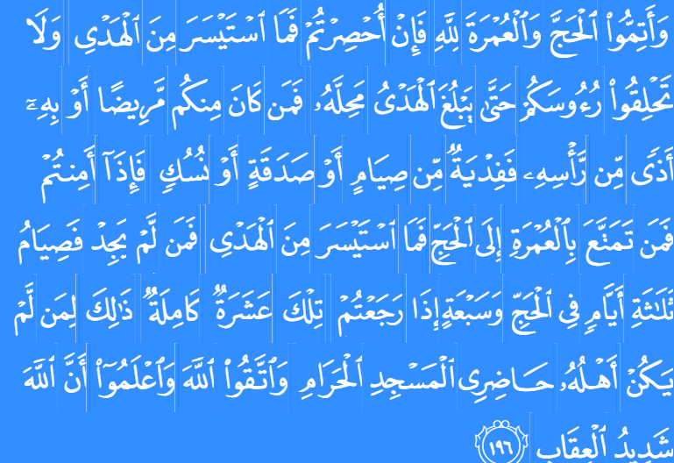SAHIH INTERNATIONAL

And complete the Hajj and 'umrah for Allah . But if you are prevented, then [offer] what can be obtained with ease of sacrificial animals. And do not shave your heads until the sacrificial animal has reached its place of slaughter. And whoever among you is ill or has an ailment of the head [making shaving necessary must offer] a ransom of fasting [three days] or charity or sacrifice. And when you are secure, then whoever performs 'umrah [during the Hajj months] followed by Hajj [offers] what can be obtained with ease of sacrificial animals. And whoever cannot find [or afford such an animal] - then a fast of three days during Hajj and of seven when you have returned [home]. Those are ten complete [days]. This is for those whose family is not in the area of al-Masjid al-Haram. And fear Allah and know that Allah is severe in penalty.
Mina 10th and 12th Dhul hijjah:
Following are the things performed between 10 and 12 Dhul hijjah .
- Rami –this is to performed on each day
- Nahr(Animal Sacrifice)
- Halaq(shaving or trimming hair)
- Tawaf al Ziyarah
- Rami is performed on 10th ,11th,12th Dhul Hijjah.
Tawaf al –wada:
Performing Farewell Tawaf before exiting Makkah .

